What to do about aquatic weeds?

2021 April 2

By David Lean, BASC (Chemical Engineering), PhD (FreshWater Biology), Environment Canada, National Water Research Institute, Section Head Nutrients and Contaminants (to 1996), University of Ottawa, Director of Ecotoxicology Program (to 2010), and currently President of Jack’s Lake Association.

# Key Points

All known treatment methods seem to only make the weed problems more persistent and problematic. Milfoil has a cycle and will become less troublesome in about 8 years if you just let nature take its course.

There is no benefit to using the herbicide Reward as it does not kill the roots and proliferation in years following treatment the problem becomes worse. In addition, there is the potential that the herbicide will kill fish, birds, and mammals as well as potentially contaminate yours or your neighbors’ drinking water.

The proven answer is to use a regular garden rake and spend 20 minutes or so every week during the growing season and remove the weeds near your dock and take them to an area about 30 m from the shore where they will become compost.

# What is a weed?

It is a plant that people do not want whether it is in your garden, lawn or lake. I prefer to refer here to aquatic plants and they are not weeds but essential parts of the lake ecosystem with many benefits. There is a broad diversity of aquatic plants in lakes and they provide valuable habitat for fish. Most fishermen know that you catch fish at weed beds. There are at least 15 different species in Jack’s Lake. It is important that this diversity is maintained as it is the native species that help to keep invasive species like Eurasian Milfoil under control (see photograph). This is the plant that currently is the biggest problem but there are others that could be introduced that are much worse. The scientific name is *Myriophyllum spicatum.* It is an invasive species and like all invasive species has an advantage at first until other factors come into play which control their abundance.

The source of Milfoil to our lake is unknown but likely was introduced by a boat from a lake where it was abundant. It is not unique to our lake but is a problem across Canada and the USA. It can only grow where the light level is sufficient (usually down to about 6 m in Jack’s Lake) and where there is ample nutrients in sediments that are suitable for growth. More specifically they require quite high levels of the limiting nutrient phosphorus which comes from river inflows, shoreline erosion, leaky septic tanks and lawn fertilizer. We are now trying to set up a program to eliminate future exotic species introductions.

I can’t emphasize enough that control of phosphorus is the key to having a healthy lake. A lake with nice clear water, like our lake, has a phosphorus level less than 10 micrograms per liter. However, an increase to only 20 micrograms per liter will cause a lake to become eutrophic or highly productive and it will have a green scum of algae often consisting of Cyanobacteria species or blue green algae that can be potentially toxic to people and animals. One 50 pound bag of 10:10:10 fertilizer would turn Brookes Bay into a colour of pea soup, with floating mats of blue green algae which may be toxic. Weed growth would follow and be so thick you could not drive your boat through it. When algae sink to the deep water they use more oxygen that they produce, depleting oxygen in the water and suffocating deep cold water fish like lake trout. Even more importantly, the sediments become also depleted in oxygen and the invertebrates so important in sustaining fish are lost.

Phosphorus, especially from fertilizer is all bioavailable and will contribute to weed growth at your dock and also cause the slippery scum on the rocks. Lakes here on the Canadian Shield have nice clear water and beautiful shorelines with native vegetation, yet many people do want to change the native vegetation and grow grass! Grass does very poorly on soils here because much of it is low in calcium but high in iron and aluminum. The low level of calcium also exists in the water and has likely saved us from in infestation of zebra mussels.

# What can you do to minimize weed growth?

If you have a lawn and weeds at the dock, what should you do? The answer is don’t use fertilizer and don’t try to grow invasive plants including flowers. Do nothing! Let the native grasses grow back, let the leaves and pine needles fall to provide natural enrichment. No one had to maintain the Jack’s Lake ecosystem throughout its history but now some people want to change that. Perhaps cut a walking path through the grass as it ages and native species come back. You will be surprised that you will have a symphony for flowers over the season as the lawn goes back to nature.

Catherine Collins covered this very nicely in *Cottage Life,* August 2018, in a text she called “9 easy ways to get a beautiful shoreline and a healthy lake”. She provided the following advice:

1. DoLess Work. (As I said above, let it go back to nature)
2. Learn the true value of what is there (know native species and even bring a few back from the forest and replant them).
3. Minimize your mowing.
4. Recreate a “Living” Shore. She points out that all you have to do is stop clearing vegetation and removing deadfall from the shallows for a shoreline to slowly repair itself. But you can lend a hand by planting a buffer of native species from water’s edge to drier land.
5. Don’t harden your shoreline (In the past, retaining walls were sought to combat erosion. People thought that it’s going to hold my shoreline together but over the years we’ve definitely found out these hardened structures do more damage than good.
6. As discussed above, she recommends not to add to your lakes’ nutrient load.
7. Don’t sacrifice your trees for better sightlines. (We all do this. We cut down trees so we get a better view but do it carefully so that it does not contribute to more erosion.)
8. Don’t wage war on water weeds. She states “You hate them, we get it. Clogging up your prop or snaking around your ankles when you swim, water weeds seem to have no purpose but to drive you crazy. They oxygenate the water and improve its clarity by impeding waves and wind that stir up sediment, says Dan Taillon, an aquatic biologist with the Ministry of Natural Resources and Forestry (MNRF) in Peterborough. The weeds provide a vital underwater sanctuary for aquatic wildlife.
9. Avoid big wakes that cause erosion. Larger boats, in particular the wakeboarding style with a water-filled ballast bag designed to make “super-big wakes.” These eat into the banks and send out large plumes of silt.Big waves can be a major cause of nest failure, washing away the eggs or drowning Loon chicks

# What is the impact of using herbicides directly in the lake?

In 2020, the JLA received complaints that some cottagers used chemicals in our lake to kill weeds in front of their cottage. Permits were issued for use in Sharpe’s Bay. I contacted the Ministry of the Environment, Conservation and Parks – Peterborough District who issued the permit and I got a copy of the permit which identifies the location and the company involved. Everything was quite legal (but I believe that critical errors were made in giving the licence). This herbicide has been approved by the Pesticide Management Regulatory Agency (PMRA) of Health Canada for use in slow-moving bodies of water including lakes, reservoirs, marches, ditches, canals, streams and rivers for the control of aquatic weeds that limit boating channels. Specifically it was for use for situations where weeds impede navigation (e.g., communal boat traffic in marina’s or small navigation channels) and might be a preferable alternative to dredging. This is not the case where it was approved here. It was not approved by PMRA for cosmetic use and so there is some debate about whether a permit should have been given. Reward contains 37.3% Diquat dibromide as the active ingredient. It kills both invasive and native aquatic plant species. Native plants are important for the health of the lake ecosystem. This too results in enhanced weed growth and makes a home for even more troublesome weeds in the future.

FOCA’s publication entitled “Healthy Waterfronts” has this to say about weed control. “Toxic Herbicides Should be Avoided! They may, or may not, control aquatic plants quickly in the short-term, but can be expensive, may have to be used often to be effective, and have negative side effects. Herbicides are especially discouraged within a wide area where anyone will be swimming, or where water intakes are nearby. Using these chemicals has health and environmental risks, and always requires a Ministry of the Environment, Conservation and Parks and/or Parks Canada permit.”

If you do a Google search you will find many pages from people who want to sell it or apply it to the problem. More scholarly articles tell a different story (eg. US Environmental Protection Agency and Cornell University). Diquat dibromide is toxic to fish and food organisms on which fish survive (so likely it killed this year’s young fish that still stay near shore. It is also moderately toxic to mammals, birds, and even humans. In human Diquat poisoning cases, clinical signs of neurologic toxicity tend to be the most significant. They include nervousness, irritability, restlessness, diminished reflexes, disorientation, nonsensical statements, and inability to recognize friends or family members. Parkinson’s disease has also been reported following dermal exposure to Diquat.

Along with the Diquat, a non-ionic detergent is included and it is not regulated by PMRA. The company does not identify what it is but there is considerable research on these compounds now and some are even more toxic than the active ingredient.

When you go swimming, notice that near shore the water is a little warmer. This temperature gradient means that there is not good mixing between the water near shore and the main lake. If you don’t believe me take a glass of milk to your dock on a calm morning and throw it in. Watch what happens as the currents take it away. Often it moves as a blob and is dispersed slowly. One would expect that the same pattern happens with adding a pesticide when added to the lake. In other words, it moves as a blob from where it is used to your water intake and your neighbors water intake. This poses a serious health problem that was not considered when the permits were issued.

I am sure that the people who used the herbicide did not appreciate the potential consequences. The licensed applicator has gone on record as saying it is safe. I do hope that the people that used the herbicide continue to record observations and keep in touch with me so we can learn the longer term effects. I predict that in the following years the problem will be worse where the Reward has been used compared to places where there was no treatment. The reason I say this is that it only kills the stems and leaves of the plant and the roots are healthy and intact. Once weeds are killed, the invasive species tend to proliferate. If Reward is used, the problem will likely persist and people are caught in a cycle of yearly application. The cost per treatment I have heard is about $500.

I will make additional contacts with the Ministry of the Environment, Conservation and Parks – Peterborough District to make sure they are aware that Sharpe’s Bay has been given a unique designation of having Trout Lake Status and requires special protection.

# Lessons from other sites

We can learn from how people from other lakes dealt with the problem we now face. At Chemong Lake, Eurasian milfoil weeds grew so thick 25 years ago that it was impossible to drive your boat through the weed beds. It was much worse than anything we have seen here. After about 8 years these weeds were not as abundant. Fishermen wondered what happened to their wonderful weed beds where they used to fish. The weeds derive all their required nutrient phosphorus from the sediment and if the level is high, there will be more weeds. Similar observations have been made in other lakes across Canada. It seems that the problem will run its course and achieve a balance where milfoil is no longer as big a problem.

We follow the work of Professor Eric Sager of Trent University who is doing research on projects which focus on the ecology and management of invasive aquatic plants. He advises the Chandos Lake Group and they will determine growth rates of aquatic plants in certain areas. They have evaluated mats to keep the weeds from around your dock. However, the mats must be removed in the fall and this is not an easy job. He also examined the potential for introducing weevils as in the Big Cedar Lake Study (costing an estimated $250,000). Their main conclusion was that short term benefits can be achieved but in the following years the biomass returns. The weevils did not live through our northern winters. Eric also partnered with the Kawartha Lakes Stewards Association to educate shoreline residents about the ecology and management of aquatic plants. He gave a lecture at their AGM 2 years ago and concluded that letting nature take its course is best.

There is a recent promotion for techniques to provide aeration, blowers, or other physical movement of water, sediments, and weeds. These should be approached with caution as they seem to get rid of weeds at your dock but will create a bigger problem further away. We have been told for many years not to leave the cuttings or parts of the weed as it will result in establishing weeds elsewhere. Weed cutters are available but unless the weeds are harvested, there are problems that result. Putting mats or screens down may reduce the abundance of milfoil but at the same time destroys native species as well. We also need to check with MNRF as some regulations are involved and the mats may need to be removed in the fall (when the water is cold).

The proven answer is to use a regular garden rake and spend 20 minutes or so every week during the growing season and remove the weeds near your dock and take them to an area about 30 m from the shore where they will become compost. A dethatching rake works even better (available at most hardware stores) and even gets the roots but keeps the weeds from breaking up in pieces for easy removal. I also quite like the Jaws Weed Rake which is better suited to get the weeds out of the water (see [https://jawsweedrake.com](https://jawsweedrake.com/)).

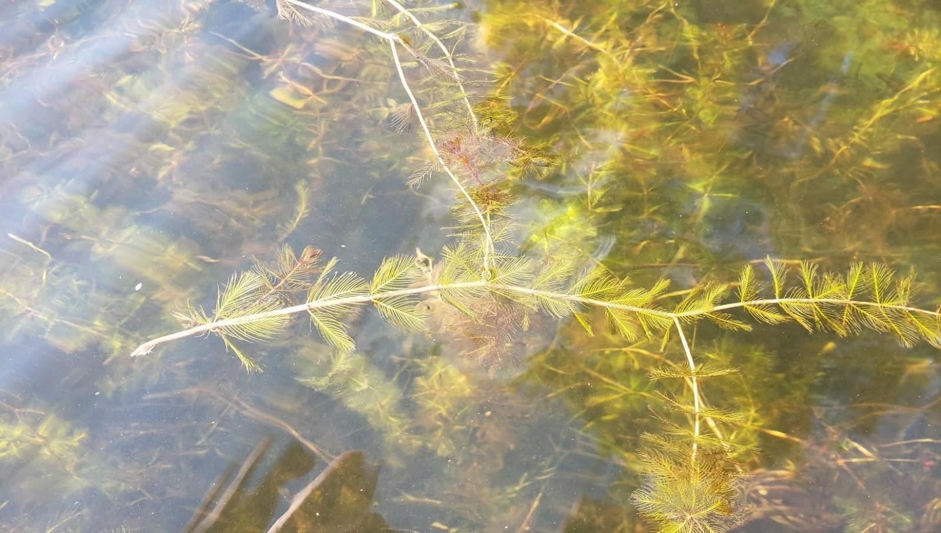

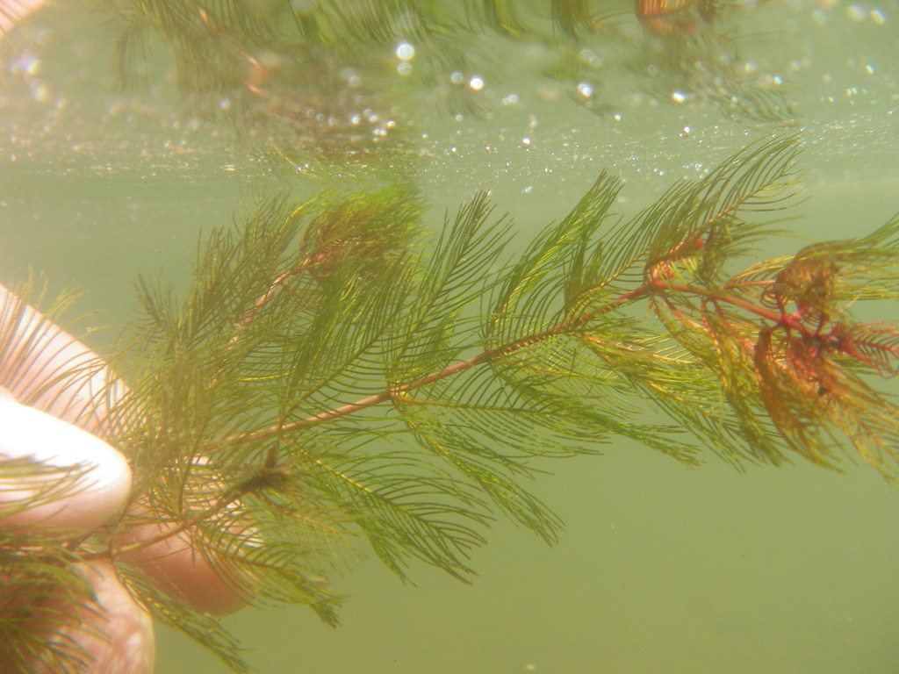

Photographs of the invasive species Eurasian Milfoil (*Myriophyllum spicatum*)